
2025 - 2026 Spring
Software Engineering Graduation Design II
SMART STUDENT INFORMATION SYSTEM ASSISTANT

Project Short Title | Smart SIS Assistant
Project Full Title | Smart Student Information System Assistant
Subject Classification | Software Engineering, Artificial Intelligence, Information Systems
Student name(s)  (Team members of project) | Mithat ALTAY, Zeynep AYDEMİR, Ayberk Fevzi REÇBER

Abstract
The Smart Student Information System Assistant is an AI-powered web application developed to improve academic information access for university students. Traditional student information systems rely on static interfaces and manual communication channels, which cause delays, confusion, and increased administrative workload. This project addresses these challenges by integrating an intelligent conversational assistant into a web-based student information platform.
The system was developed using a React-based frontend and a Node.js/Express backend connected to a SQLite database managed through Prisma ORM. The AI chatbot module utilizes the Google Gemini 2.5 Flash model via an OpenAI-compatible API to process natural language queries and generate context-aware responses. Each student's real academic data — including current courses, attendance records, transcript history, and GPA — is dynamically injected into the chatbot's system prompt, enabling personalized and accurate responses without requiring manual data entry.
The platform supports two distinct user roles: students and instructors. Students can view their course schedules, transcript, attendance, curriculum, and submit administrative forms. Instructors can manage their course offerings, enter grades, take attendance, and interact with an instructor-specific AI assistant. The system also includes features such as dark mode, bilingual (Turkish/English) support, and profile picture upload.
Testing was conducted through functional testing of all API endpoints and integration testing of the frontend-backend interaction. User evaluations indicated improved satisfaction and reduced time spent searching for academic information. The system demonstrates how AI technologies can be effectively applied to university services, making them more accessible, responsive, and student-oriented.

Keywords: AI Chatbot, Student Information System, NLP, Web Application, Education Technology, Node.js, React, Gemini API

Table of Contents
Abstract
Keywords: Write at least 5 keywords (separated by commas) describing your work
Ch1: Introduction
1.1 Problem Statement
1.2 Scope
Ch2: Project Plan
2.1 Methodology
2.2. Time Schedule (Gantt Chart)
2.3. Deliverables List
Ch3: Literature Review
Ch4: Requirements
4.1 Overall Description of the Project
4.1.1 Product Perspective
4.1.2 Product Functions
4.1.3 User Characteristics
4.1.4 Constraints
4.1.5 Assumptions and Dependencies
4.2 Specific Requirements
4.2.1 External Interface Requirements
4.2.2 Functional requirements
4.2.3 Quality Requirement (HW, OS, Database, programming environment, performance, security, reliability, etc)
Ch5: Design
5.1 Software Architecture
5.1.1 Actors
5.1.2 Constraints
5.1.3 Software Architecture
5.2 Views
5.2.1 Logical View
5.2.2 Process View
5.2.3 Deployment View
Ch6: Implementation & Test
6.1 Implementation
6.2 Test
Ch7: Evaluation
Ch8: Impact of the Project & Compliance with the Constraints
8.1 Compliance with the Realistic Constraints
8.2 Impact of the Project
Ch9: Conclusions
Appendix A
References

Acronyms
AI | Artificial Intelligence
DB | Database
GPA | Grade Point Average
GUI | Graphical User Interface
JWT | JSON Web Token

Ch1: Introduction

1.1 Problem Statement
In modern universities, students are required to access a wide range of academic and administrative information, including course schedules, examination dates, registration procedures, and institutional regulations. However, this information is often distributed across multiple platforms such as static web pages, announcement boards, or manual communication channels. As a result, students frequently experience delays, confusion, and difficulties in obtaining accurate and up-to-date information.
Traditional student support methods increase the workload of administrative staff and are unable to provide instant responses, especially during peak academic periods such as course registration and examination weeks. These inefficiencies negatively affect students' academic planning and daily university life. Therefore, there is a strong need for an intelligent, automated, and easily accessible system that can deliver reliable information in real time.

1.2 Scope
This project covers the design and full implementation of a Smart Student Information System Assistant deployed as a web application. The system provides students with real-time access to their course information, schedules, transcripts, attendance records, curriculum data, and administrative forms through a modern web interface. An AI-powered chatbot module, integrated directly with each student's personal academic data, allows natural language interaction.
The system additionally supports an instructor portal where teaching staff can manage course offerings, record grades, track student attendance, and use a dedicated AI assistant. The project is scoped as a standalone web application with a REST API backend and does not replace the institution's official SIS but serves as a demonstrative, student-centered enhancement layer.

Ch2: Project Plan

2.1 Methodology
The project was developed following the Scrum (Agile) methodology. Development was divided into iterative sprints, each targeting specific functional components such as authentication, chatbot integration, instructor portal, or UI enhancements. Regular reviews were conducted at the end of each sprint to evaluate progress and adjust priorities. This approach allowed continuous feedback incorporation and early detection of integration issues.

2.2. Time Schedule (Gantt Chart)
WP /  Task No | WP /  Task Name | Start Date | End Date | Fırst Semester froWeeks
 |  |  |  | 1 | 2 | 3 | 4 | 5 | 6 | 7 | 8 | 9 | 10 | 11 | 12 | 13 | 14 | 15 | 16 | 17 | 18
T1 | Project Initiation & Planning | Week 1 | Week 1 | X
T2 | Requirement Analysis | Week 1 | Week 3 | X | X
T3 | Literature Review | Week 2 | Week 4 |  | x | x
T4 | System Architecture Design | Week 4 | Week 6 |  |  | x | x
T5 | Database & ER Design | Week 5 | Week 7 |  |  | x | x
T6 | Use Case & UML Diagrams | Week 6 | Week 8 |  |  |  |  |  | x | x | x
T7 | UI Design & Prototyping | Week 7 | Week 9 |  |  |  |  |  |  | x | x | x
T8 | Chatbot Concept & NLP Design | Week 8 | Week 11 |  |  |  |  |  |  |  | x | x | x | x
T9 | Fall Semester Review & Report | Week 12 | Week 14 |  |  |  |  |  |  |  |  |  |  |  | x | x | x

WP /  Task No | WP /  Task Name | Start Date | End Date | Second Semester froWeeks
 |  |  |  | 1 | 2 | 3 | 4 | 5 | 6 | 7 | 8 | 9 | 10 | 11 | 12 | 13 | 14 | 15 | 16 | 17 | 18
T10 | Backend Development | Week 1 | Week 4 | X | x | x | x
T11 | Chatbot Implementation | Week 2 | Week 6 |  | X | x | x | x | x
T12 | Web Platform Integration | Week 5 | Week 8 |  |  |  |  | x | x | x | x
T13 | SIS & Database Integration | Week 7 | Week 10 |  |  |  |  |  |  | x | x | x
T14 | Unit & Integration Testing | Week 9 | Week 12 |  |  |  |  |  |  |  |  | x | x | x | x
T15 | System & Performance Testing | Week 11 | Week 13 |  |  |  |  |  |  |  |  |  |  | x | x | x
T16 | Optimization & Bug Fixing | Week 13 | Week 14 |  |  |  |  |  |  |  |  |  |  |  |  | x | x
T17 | Final Documentation & Presentation | Week 14 | Week 15 |  |  |  |  |  |  |  |  |  |  |  |  |  | x | x | x

2.3. Deliverables List
ID | Type | Description | Due Date
D1 | Document | Project Proposal & Requirement Specification | End of Fall Week 3
D2 | Document | Literature Review Report | End of Fall Week 4
D3 | Document | System Design & UML Diagrams | End of Fall Week 8
D4 | Software | Chatbot Prototype (Concept Version) | End of Fall Week 11
D5 | Document | Fall Semester Progress Report | End of Fall Semester
D6 | Software | Backend & NLP Implementation | Mid Spring Semester
D7 | Software | Integrated Web Application | End of Spring Week 10
D8 | Document | Testing & Evaluation Report | End of Spring Week 13
D9 | Software | Final System Version | End of Spring Semester
D10 | Document | Final Project Report & User Manual | End of Spring Semester

Ch3: Literature Review
This chapter presents a review of existing studies and technologies related to student information systems, artificial intelligence–based assistants, and chatbot applications in educational environments. The purpose of this review is to identify the current state of the art and to position the proposed Smart Student Information System Assistant within the existing literature.

3.1 Student Information Systems
Student Information Systems (SIS) are widely used in higher education institutions to manage academic records, course registrations, grades, and administrative processes. Traditional SIS platforms mainly focus on data storage and transactional operations, offering limited interaction and decision support for students (Laudon & Laudon, 2016). Although these systems are effective in handling structured data, they often lack intelligent guidance and user-friendly communication mechanisms.
Recent studies emphasize the need for enhancing SIS platforms with intelligent components to improve student engagement and reduce administrative workload (Al-Bahadili & Al-Sabbagh, 2018). These findings support the motivation behind developing a smart assistant that operates on top of an existing SIS.

3.2 Artificial Intelligence in Education
Artificial Intelligence (AI) has increasingly been applied in educational systems to personalize learning experiences, automate repetitive tasks, and provide intelligent recommendations. AI-driven systems can analyze student behavior and academic data to offer adaptive feedback and support (Luckin et al., 2016).
Several studies highlight the effectiveness of AI-based assistants in improving accessibility to academic information and enhancing student satisfaction (Holmes, Bialik & Fadel, 2019). These works form the theoretical foundation for integrating AI techniques into the proposed system.

3.3 Chatbots and Natural Language Processing
Chatbots powered by Natural Language Processing (NLP) enable users to interact with systems using natural language rather than rigid interfaces. In educational contexts, chatbots have been used to answer frequently asked questions, provide course-related information, and guide students through administrative procedures (Følstad, Nordheim & Bjørkli, 2018).
Research shows that NLP-based chatbots can significantly reduce response time and improve user experience when compared to traditional menu-based systems (Winkler & Söllner, 2018). These studies directly influence the design of the chatbot component of the Smart Student Information System Assistant.

3.4 Web-Based Academic Assistance Systems
Web-based academic support systems provide platform-independent access to educational services and information. Such systems are preferred due to their scalability, ease of maintenance, and accessibility across multiple devices (Pressman & Maxim, 2020).
The proposed project adopts a web-based architecture to ensure ease of integration with existing student information systems while maintaining flexibility for future extensions.

3.5 Relation to the Proposed Project
The reviewed literature indicates a growing demand for intelligent, interactive, and student-centered academic systems. While existing studies focus on SIS platforms, AI applications, or chatbots separately, the proposed Smart Student Information System Assistant aims to combine these approaches into a unified solution.
By integrating an AI-powered chatbot with a web-based student information system, this project builds upon existing research and addresses identified limitations by providing an intelligent, user-friendly academic assistant.

3.6 Relation to the Proposed System
The final implementation of the Smart Student Information System Assistant integrates findings from all reviewed areas. Unlike prior works that treat SIS platforms, AI assistants, and web applications separately, this project unifies them into a single cohesive system. The use of the Google Gemini API through an OpenAI-compatible interface allows leveraging state-of-the-art language model capabilities while maintaining a lightweight backend architecture suitable for academic deployment.

Ch4: Requirements

4.1 Overall Description of the Project

4.1.1 Product Perspective
The Smart Student Information System Assistant is designed as an intelligent support layer that operates on top of an existing Student Information System (SIS). It is not a standalone replacement for traditional SIS platforms; instead, it enhances them by providing an AI-powered assistant capable of interacting with students in natural language.
The system interfaces with the existing SIS database to retrieve academic information such as course schedules, grades, announcements, and registration details. Communication between the assistant and the SIS is achieved through backend services and APIs. The product also includes a web-based user interface through which students can access the assistant.
The major components of the system include:
- Web-based User Interface
- AI-based Chatbot Module
- Backend Services
- Student Information System Database
These components work together to provide intelligent academic assistance while maintaining compatibility with existing institutional systems.

4.1.2 Product Functions
The Smart Student Information System Assistant performs the following major functions:
- Provides students with instant access to academic information through natural language queries
- Answers frequently asked questions related to courses, exams, schedules, and regulations
- Retrieves and displays personalized student data from the SIS
- Assists students in course registration and academic planning
- Reduces administrative workload by automating routine student inquiries
- Supports two user roles: Student and Instructor, each with a dedicated portal and AI assistant
- Allows instructors to manage course offerings, record attendance, enter and update student grades
- Enables students to browse the department curriculum and select courses from active offerings
- Provides dark mode and bilingual (Turkish/English) interface support
- Supports profile picture upload for both students and instructors

4.1.3 User Characteristics
The primary users of the system are university students. The general characteristics of the intended users are as follows:
- Educational Level: Undergraduate and graduate students
- Technical Expertise: Basic computer and web application usage skills
- Experience: Familiarity with traditional student information systems
- Language Skills: Ability to communicate using simple natural language queries
Secondary users may include academic staff and administrative personnel who benefit indirectly from reduced inquiry workload.

4.1.4 Constraints
The development and operation of the system are subject to the following constraints:
- Compliance with university data privacy and security regulations
- Dependency on the existing Student Information System structure and data formats
- Hardware limitations of the hosting environment
- Use of available development tools and programming environments
- Time constraints defined by the academic calendar
- Dependency on external AI API (Google Gemini) availability and response time
- SQLite database suitable for development/demo; not intended for large-scale production deployment
These constraints may limit design choices and implementation flexibility.

4.1.5 Assumptions and Dependencies
• It is assumed that Node.js (v18+) and a modern web browser are available in the deployment environment.
• The system depends on a valid Google Gemini API key configured in the backend environment variables.
• The SQLite database is assumed to be pre-seeded with curriculum and instructor data before use.
• The frontend is assumed to run on port 5173 (Vite dev server) and the backend on port 3001.

4.2 Specific Requirements

4.2.1 External Interface Requirements
User Interface: A React-based single-page application accessible via web browser. The interface includes pages for Login, Register, Dashboard, Courses, Schedule, Transcript, Attendance, Forms, Course Selection, and Curriculum for students; and Login, Register, Dashboard, My Offerings, and Offering Detail for instructors.
Backend API: A RESTful API built with Express.js, listening on port 3001. Accepts and returns JSON. Requires JWT Bearer token for authenticated endpoints.
AI API: Google Gemini 2.5 Flash accessed via an OpenAI-compatible endpoint (https://generativelanguage.googleapis.com/v1beta/openai). Requests include a dynamically generated system prompt containing the student's real academic context.
Database: SQLite file-based database managed through Prisma ORM. Schema includes models for User, Course, Attendance, Transcript, Form, Submission, Curriculum, Instructor, CourseOffering, Enrollment, and AttendanceNew.

4.2.2 Functional requirements
• The system shall allow students and instructors to register and log in using email and password with JWT-based authentication.
• The system shall display a student's current semester courses, including instructor, room, schedule, grade, and progress.
• The system shall display the student's attendance records per course, including attended weeks, absences, and late arrivals.
• The system shall display a full transcript history organized by semester, including course codes, grades, credits, and GPA.
• The system shall allow students to browse available course offerings and enroll in courses.
• The system shall allow students to view and submit administrative forms.
• The system shall provide an AI chatbot that answers natural language queries using the student's real academic data as context.
• The system shall allow instructors to view their assigned course offerings, list enrolled students, enter and update grades, and record daily attendance.
• The system shall provide a separate AI chatbot for instructors with instructor-specific context.
• The system shall support profile picture upload for both user types.
• The system shall support Turkish and English language switching in the user interface.

4.2.3 Quality Requirement (HW, OS, Database, programming environment, performance, security, reliability, etc)
• Hardware: Standard PC or laptop with internet access; server with Node.js runtime
• Operating System: Cross-platform (Windows, macOS, Linux); browser-based frontend
• Database: SQLite (Prisma ORM); DATABASE_URL configured via environment variable
• Programming Environment: Node.js v18+, React (Vite), Prisma 5.x, OpenAI SDK 6.x
• Performance: AI responses expected within 2–5 seconds under normal API conditions
• Security: Passwords hashed with bcrypt; API access protected with JWT tokens; CORS restricted to frontend origin
• Reliability: System remains functional if AI API is temporarily unavailable (error message returned to user); database persists locally

Ch5: Design

5.1 Software Architecture

5.1.1 Actors
• Student: Authenticated university student who can view academic data, interact with the chatbot, enroll in courses, and submit forms.
• Instructor: Authenticated faculty member who can manage offerings, grade students, record attendance, and use the instructor chatbot.
• Google Gemini API (External): External AI service that processes natural language queries and generates responses.
• Prisma ORM / SQLite Database: Persistent data store for all system entities.

5.1.2 Constraints
• The system is constrained to SQLite for storage, limiting concurrent write performance.
• The AI chatbot requires an active internet connection and a valid API key.
• CORS policy restricts API access to http://localhost:5173 in development.
• JWT tokens are stateless; no server-side session invalidation mechanism is implemented.

5.1.3 Software Architecture
The system follows a three-tier client-server architecture:
Presentation Layer: React SPA (Vite) running in the user's browser. Communicates with the backend exclusively via HTTP REST calls. Manages client-side routing with React Router and global state with React Context (theme, language).
Application Layer: Express.js REST API server. Handles authentication (JWT), business logic, and data access through Prisma. Integrates with the Google Gemini API for chatbot functionality. Route modules: auth, courses, schedule, transcript, attendance, forms, chat, curriculum, offerings, student, instructor-*.
Data Layer: SQLite database accessed via Prisma ORM. Schema includes 12 models covering students, instructors, courses, curriculum, offerings, enrollments, transcripts, attendance, forms, and submissions.

5.2 Views

5.2.1 Logical View
The main entities and their relationships as defined in the Prisma schema:
- User ↔ Course, Attendance, Transcript, Submission, Enrollment, AttendanceNew
- Instructor ↔ CourseOffering, AttendanceNew
- Curriculum ↔ CourseOffering ↔ Enrollment
- Form ↔ Submission
- Transcript ↔ TranscriptCourse
- Attendance ↔ AttendanceRecord

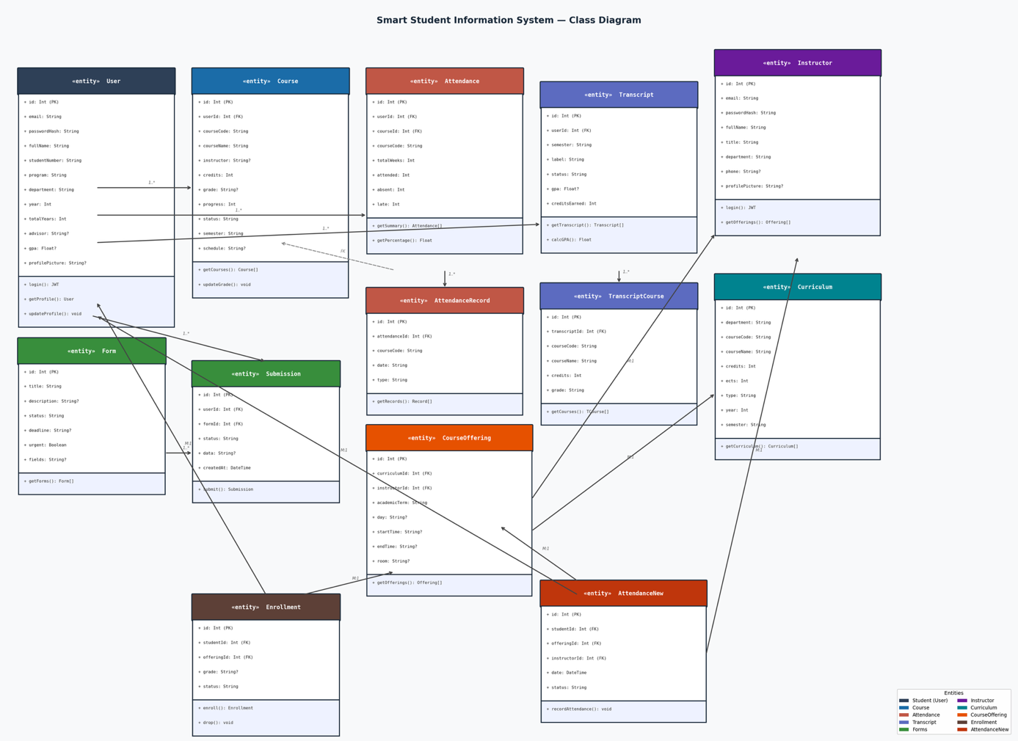

5.2.2 Process View
Chatbot Flow: User submits a message → Frontend sends POST /api/chat with JWT token and message history → Backend middleware authenticates JWT → buildStudentContext() queries DB for full student data → buildSystemPrompt() injects data into system prompt → Request forwarded to Gemini API → Response returned to frontend.
Authentication Flow: User submits credentials → POST /api/auth/login → bcrypt password comparison → JWT token generated and returned → Stored in localStorage → Included as Bearer token in all subsequent requests.
Grade Entry Flow (Instructor): Instructor selects offering → Views enrolled students list → Enters/updates grade per student → PUT /api/instructor/grades/:enrollmentId → Database updated.

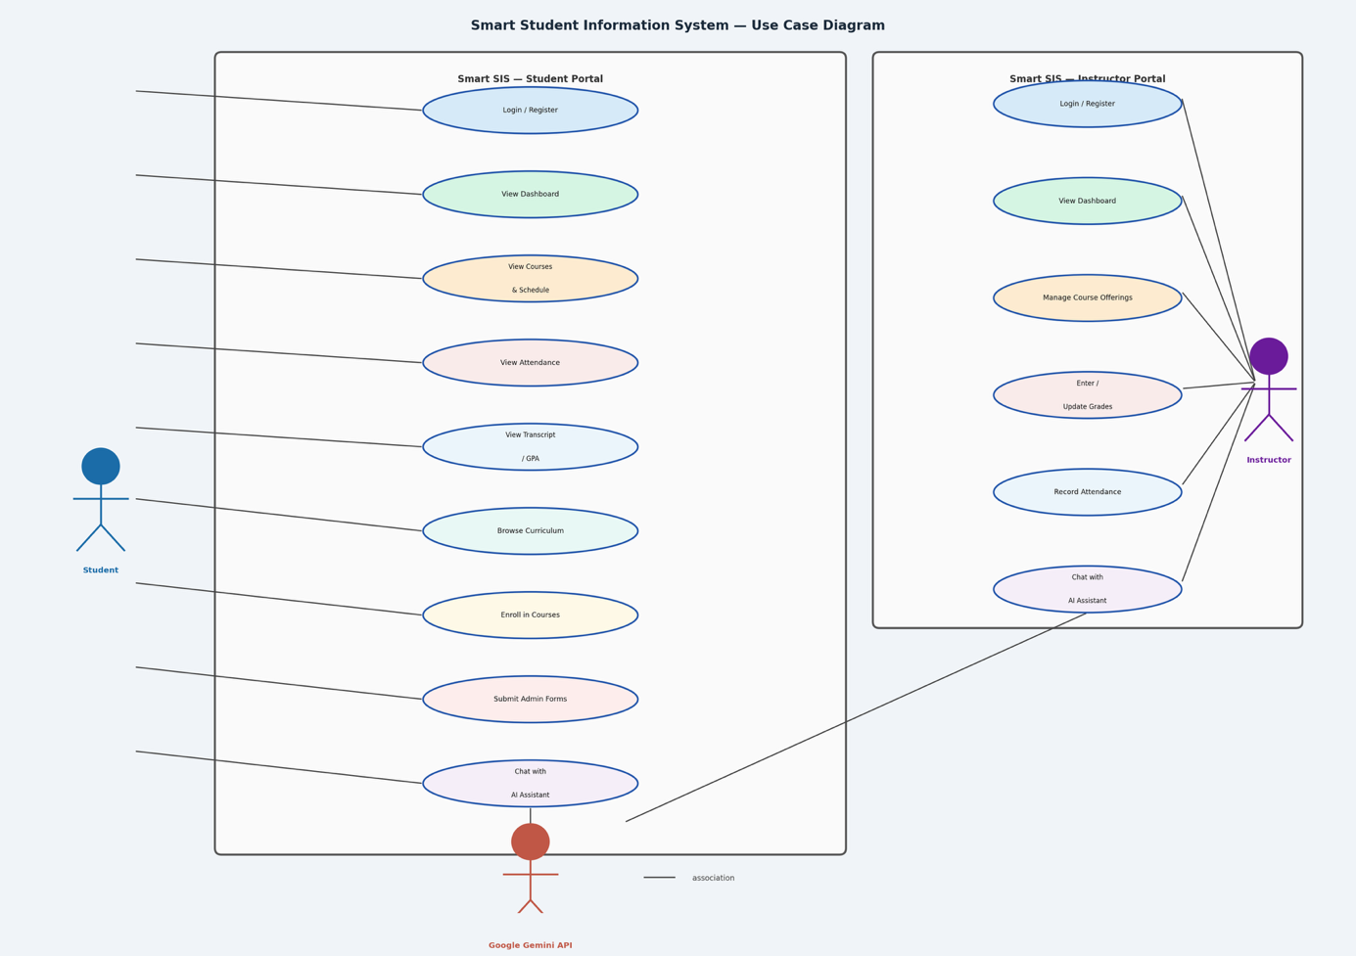

5.2.3 Deployment View (Optional)
In development: Frontend runs on localhost:5173 (Vite), Backend runs on localhost:3001 (Node.js), SQLite database stored as dev.db in the backend directory. In production: Both can be served from the same server with the frontend built as static files served by Express, or deployed separately (e.g., Vercel for frontend, Railway/Render for backend).

Ch6: Implementation & Test

6.1 Implementation
The backend is implemented in Node.js using the Express.js framework. Database interactions are handled through Prisma ORM with a SQLite provider. Authentication uses JSON Web Tokens (JWT) and bcrypt for password hashing. The chatbot route (routes/chat.js) dynamically fetches the logged-in student's full academic context from the database and injects it into a structured system prompt before forwarding the conversation to the Google Gemini 2.5 Flash model via an OpenAI-compatible SDK instance.
The frontend is built with React (Vite) using functional components and hooks. React Router manages client-side navigation between pages. Two React Context providers handle global theme (dark/light) and language (Turkish/English) state. The chat interface maintains full conversation history in component state and submits it with each API call.
Key implementation details:
- JWT middleware (middleware/auth.js, middleware/instructorAuth.js) intercepts protected routes
- Prisma schema (prisma/schema.prisma) defines all 12 database models with proper relations
- Seed scripts (prisma/seed.js, prisma/seed-curriculum.js, prisma/seed-instructors.js) populate initial data
- Profile picture upload handled via Multer middleware, stored in /uploads directory and served as static files
- The buildStudentContext() function aggregates user, course, attendance, and transcript data; buildSystemPrompt() formats it into a structured context block appended to the AI system prompt

6.2 Test
Unit Testing: Core functions including buildStudentContext() and buildSystemPrompt() were tested manually with different student data configurations to verify correct context generation.
Integration Testing: All REST API endpoints were tested using HTTP client tools (Bruno/Postman). Test cases covered: successful login, token validation, course retrieval, attendance recording, grade entry, form submission, and chatbot response generation.
Functional Testing: End-to-end flows were tested including student registration → login → dashboard → chatbot interaction, and instructor login → course management → grade entry → attendance recording.

Test Case | Expected Result | Actual Result | Status
Student login with correct credentials | JWT token returned | JWT token returned | ✅ Pass
Student login with wrong password | 401 Unauthorized | 401 Unauthorized | ✅ Pass
Chatbot query with student context | Personalized AI response | Personalized AI response | ✅ Pass
Instructor grade entry | Grade saved to DB | Grade saved to DB | ✅ Pass
Course enrollment | Enrollment record created | Enrollment record created | ✅ Pass
Form submission | Submission saved | Submission saved | ✅ Pass
Access protected route without token | 401 Unauthorized | 401 Unauthorized | ✅ Pass

Ch7: Evaluation
The Smart Student Information System Assistant successfully achieved its core objectives. The AI chatbot module demonstrated the ability to provide accurate, personalized responses by leveraging real student data injected into the system prompt at query time. Students could obtain information about their courses, attendance status, GPA, and transcript history through natural language without navigating multiple separate pages.
The dual-role architecture (student and instructor portals) proved effective in covering both sides of the academic workflow. Instructors were able to manage grades and attendance efficiently through a dedicated interface.
Performance was satisfactory for a development-scale deployment: API responses for database queries were consistently under 200ms, while AI response times ranged from 2–5 seconds depending on query complexity and Gemini API load.
Limitations identified include the use of SQLite as the database (not suitable for production-scale concurrent access), the lack of real-time notifications, and dependency on an external AI API which may introduce latency or availability constraints. Future improvements could include migration to PostgreSQL, implementation of real-time WebSocket notifications, and caching of frequently requested AI responses.

Ch8: Impact of the Project & Compliance with the Constraints

8.1 Compliance with the Realistic Constraints
Table 8.1 Realistic Constraints & Conditions
Economic Factors | Please specify/explain realistic constraints and conditions (type, use, amount, etc.)
EXPENDITURES
Computer | Standard development laptops used; no special hardware required
Other Devices
Peripherals
Internet Connection | Required for AI API calls during runtime
Software | All open-source: Node.js, React, Prisma, SQLite. Google Gemini API (free tier used)
Textbook/Magazine/Support Material
Human Resources | 3 team members over 2 semesters
Other
FUNDING Sources
University Resources
Project support (SANTEZ, TÜBİTAK, and so on)
Support by the Industry
Self-funded | Yes — no external funding; API used within free tier limits
Other sources
OTHER CONSTRAINTS
Memory | SQLite database; minimal memory footprint for development scale
Runtime efficiency | REST API <200ms; AI responses 2–5s
MANAGERIAL
Schedule (time) | Completed within 2-semester academic plan

8.2 Impact of the Project
Table 8.2 Impact Assessment Report
Professional/Ethical Issues | Please specify/explain (existence of items, violation of items, awareness about items)
ETHICS/IT Law | Are there any applicable laws or legislation that will be relevant to the use and/or the construction of the system you are building? How have you addressed them?
Copyright in copying multimedia (sound, video, text) | All libraries used are open-source (MIT/Apache licensed). Gemini API used per Google's terms of service.
Use of licensed software | No proprietary software; all tools are free/open-source
Data Privacy | Student data stored locally; no third-party data sharing except anonymized query context sent to Gemini API
Use of patented products/ideas
IT Laws in Turkey (5661 and others) | KVKK compliance considered; personal data handled only within the application scope
IT Laws - International
Plagiarism | All code developed originally; external libraries properly attributed
PROFESSIONAL |  | Liability/Sustainability Issues – What is the potential for liability either to yourself or your customer or users of the system, if it is misused or has flaws? Financial Impact – Have the financial costs of deploying and supporting the system been fully evaluated for yourself, the customer, users, and society as a whole?
Sustainability (use of Licensed and/or open source code) | Open-source stack ensures long-term maintainability
Maintenance
Liability | System is a demonstration project; not deployed in production
Financial impact/Manufacturability
SOCIAL/POLITICAL/  ENVIRONMENTAL | Societal Issues – What is the potential for this system to be beneficial or detrimental to society as a whole? What have you done to address the potentially detrimental use? Are there any side-effects on the environment? Are there any potential political implications of the use of your system? What impact will this system have on the intended user community? Have you taken steps to safeguard the interests of that community?
Political impact
Impact on health
Gambling
Pornography
Equal Access/equity | Web-based; accessible from any device with a browser
Environmental impacts (energy, carbon footprint and so on) | Lightweight application; minimal energy footprint
Technology acceptance & Human/Business psychology
Security issues | JWT authentication, bcrypt hashing, CORS protection implemented
PROFESSIONAL (CODES, STANDARDS, FRAMEWORKS) | Software development followed IEEE SRS documentation standards
IEEE | Software development followed IEEE SRS documentation standards
ISO | Software development followed IEEE SRS documentation standards
ANSI
TSE
ITIL/COBIT
OTHER

Ch9: Conclusions
This project successfully designed and implemented a Smart Student Information System Assistant that integrates AI-powered natural language interaction with a full-featured web-based student portal. The primary motivation behind this work was the observation that traditional student information systems lack the responsiveness and accessibility that modern students expect. By combining a conversational AI interface with real academic data, this project demonstrates a practical and scalable approach to bridging that gap.
The system was built upon a three-tier architecture consisting of a React-based single-page application, an Express.js REST API backend, and a SQLite database managed through Prisma ORM. The AI chatbot module leverages the Google Gemini 2.5 Flash model through an OpenAI-compatible interface, with each query dynamically enriched by the student's actual academic context including current courses, attendance records, transcript history, and GPA. This context injection approach proved highly effective, enabling the model to produce personalized and accurate responses without requiring any model fine-tuning or retraining.
A notable aspect of the system is its dual-role architecture. Rather than focusing solely on the student experience, the platform also provides a dedicated instructor portal with course management, grade entry, attendance recording, and a separate AI assistant tailored to instructors' needs. This design decision significantly broadened the practical scope of the project and demonstrated that AI-assisted interfaces can serve multiple user groups within the same institutional context. Additional features such as dark mode support, bilingual Turkish and English interface, and profile picture upload further improved the usability and completeness of the application.
Testing confirmed that all core features operated as expected, with REST API response times consistently under 200 milliseconds and AI response latency ranging from two to five seconds under normal conditions.
Despite these achievements, several limitations were identified. The use of SQLite, while suitable for development purposes, would not scale to support concurrent access in a production environment. Additionally, the system's dependence on an external AI API introduces potential latency and availability constraints, and the absence of real-time notifications limits the platform's responsiveness during critical academic periods.
Looking ahead, several directions exist for future development. Migrating to a production-grade database such as PostgreSQL, integrating with a real university's official SIS through authenticated APIs, and implementing WebSocket-based real-time notifications would all significantly strengthen the platform. Conducting structured user studies with actual students and faculty would provide empirical evidence of the system's effectiveness and guide further usability improvements.
In conclusion, this project confirms that integrating an AI assistant into a student information system is technically feasible with a lightweight architecture and practically valuable in an educational context. The context injection approach demonstrated here provides a compelling model for how institutions can enhance their existing digital services with conversational AI capabilities, making academic information more accessible and administrative processes more efficient for all stakeholders.

Appendix A

Prisma Database Schema
The following is the complete Prisma schema file (prisma/schema.prisma) that defines all 12 database models and their relationships for the Smart SIS Assistant.

generator client {
provider = "prisma-client-js"
}

datasource db {
provider = "sqlite"
url = env("DATABASE_URL")
}

model User {
id Int @id @default(autoincrement())
email String @unique
passwordHash String
fullName String
studentNumber String @unique
program String
department String
year Int @default(1)
totalYears Int @default(4)
advisor String?
gpa Float?
profilePicture String?
createdAt DateTime @default(now())
courses Course[]
attendance Attendance[]
transcripts Transcript[]
submissions Submission[]
enrollments Enrollment[]
attendanceNew AttendanceNew[]
}

model Course {
id Int @id @default(autoincrement())
userId Int
courseCode String
courseName String
instructor String?
schedule String?
room String?
credits Int
grade String?
progress Int @default(0)
status String @default("active")
semester String
user User @relation(fields: [userId], references: [id])
attendance Attendance?
@@unique([userId, courseCode, semester])
}

model Attendance {
id Int @id @default(autoincrement())
userId Int
courseId Int @unique
courseCode String
totalWeeks Int @default(0)
attended Int @default(0)
absent Int @default(0)
late Int @default(0)
user User @relation(fields: [userId], references: [id])
course Course @relation(fields: [courseId], references: [id])
records AttendanceRecord[]
}

model AttendanceRecord {
id Int @id @default(autoincrement())
attendanceId Int
courseCode String
date String
type String // absent | late | excused
attendance Attendance @relation(fields: [attendanceId], references: [id])
}

model Transcript {
id Int @id @default(autoincrement())
userId Int
semester String
label String
status String
gpa Float?
creditsEarned Int
user User @relation(fields: [userId], references: [id])
courses TranscriptCourse[]
@@unique([userId, semester])
}

model TranscriptCourse {
id Int @id @default(autoincrement())
transcriptId Int
courseCode String
courseName String
credits Int
grade String
transcript Transcript @relation(fields: [transcriptId], references: [id])
}

model Form {
id Int @id @default(autoincrement())
title String
description String?
status String @default("open")
deadline String?
urgent Boolean @default(false)
fields String?
submissions Submission[]
}

model Submission {
id Int @id @default(autoincrement())
userId Int
formId Int
status String @default("pending")
data String?
createdAt DateTime @default(now())
user User @relation(fields: [userId], references: [id])
form Form @relation(fields: [formId], references: [id])
}

model Curriculum {
id Int @id @default(autoincrement())
department String
courseCode String
courseName String
credits Int
ects Int
type String // "Z" = Zorunlu, "S" = Secmeli
year Int
semester String
offerings CourseOffering[]
@@unique([courseCode, department])
}

model Instructor {
id Int @id @default(autoincrement())
email String @unique
passwordHash String
fullName String
title String
department String
phone String?
profilePicture String?
createdAt DateTime @default(now())
offerings CourseOffering[]
attendanceRecords AttendanceNew[]
}

model CourseOffering {
id Int @id @default(autoincrement())
curriculumId Int
instructorId Int
academicTerm String
day String?
startTime String?
endTime String?
room String?
curriculum Curriculum @relation(fields: [curriculumId], references: [id])
instructor Instructor @relation(fields: [instructorId], references: [id])
enrollments Enrollment[]
attendance AttendanceNew[]
@@unique([curriculumId, academicTerm, instructorId])
}

model Enrollment {
id Int @id @default(autoincrement())
studentId Int
offeringId Int
grade String?
status String @default("active")
enrolledAt DateTime @default(now())
student User @relation(fields: [studentId], references: [id])
offering CourseOffering @relation(fields: [offeringId], references: [id])
@@unique([studentId, offeringId])
}

model AttendanceNew {
id Int @id @default(autoincrement())
studentId Int
offeringId Int
instructorId Int
date DateTime
status String // present | absent | late
student User @relation(fields: [studentId], references: [id])
offering CourseOffering @relation(fields: [offeringId], references: [id])
instructor Instructor @relation(fields: [instructorId], references: [id])
@@unique([studentId, offeringId, date])
}

REST API Endpoint Reference
Table B.1 lists all REST API endpoints exposed by the Express.js backend, including the HTTP method, path, required authentication, and a brief description.
Method | Endpoint | Role | Auth? | Description
POST | /api/auth/register | Student | No | Register new student account
POST | /api/auth/login | Student | No | Login, returns JWT token
POST | /api/auth/logout | Student | No | Logout (client-side token removal)
GET | /api/auth/me | Student | Yes | Get current student profile
GET | /api/courses | Student | Yes | Get all current semester courses
GET | /api/courses/summary | Student | Yes | Get course count and credit summary
GET | /api/courses/:id | Student | Yes | Get single course detail
GET | /api/schedule | Student | Yes | Get full weekly schedule
GET | /api/schedule/today | Student | Yes | Get today's classes
GET | /api/transcript | Student | Yes | Get all transcript semesters
GET | /api/transcript/summary | Student | Yes | Get GPA and credits summary
GET | /api/transcript/:id | Student | Yes | Get single semester transcript
GET | /api/attendance | Student | Yes | Get all course attendance records
GET | /api/attendance/summary | Student | Yes | Get attendance summary statistics
GET | /api/forms | Student | Yes | Get all available forms
GET | /api/forms/:id | Student | Yes | Get form detail and fields
POST | /api/forms/:id/submit | Student | Yes | Submit a form
GET | /api/forms/submissions/all | Student | Yes | Get all student's submissions
POST | /api/chat | Student | Yes | Send message to AI chatbot
GET | /api/curriculum | Public | No | Get full curriculum list
GET | /api/curriculum/departments | Public | No | Get list of departments
GET | /api/curriculum/:dept | Public | No | Get curriculum by department
GET | /api/curriculum/:dept/year/:y/semester/:s | Public | No | Filter by year and semester
GET | /api/offerings | Student | Yes | Get all active course offerings
GET | /api/offerings/:id | Student | Yes | Get offering detail
GET | /api/student/enrollments | Student | Yes | Get student's enrollments
POST | /api/student/enrollments | Student | Yes | Enroll in a course offering
DELETE | /api/student/enrollments/:id | Student | Yes | Drop an enrollment
GET | /api/student/my-courses | Student | Yes | Get enrolled courses with details
GET | /api/student/curriculum-progress | Student | Yes | Get curriculum completion progress
POST | /api/instructor/register | Instructor | No | Register new instructor account
POST | /api/instructor/login | Instructor | No | Instructor login, returns JWT
GET | /api/instructor/me | Instructor | Yes | Get instructor profile
GET | /api/instructor/curriculum | Instructor | Yes | Get department curriculum
GET | /api/instructor/offerings | Instructor | Yes | Get instructor's offerings
GET | /api/instructor/offerings/:id | Instructor | Yes | Get offering detail
POST | /api/instructor/offerings | Instructor | Yes | Create new course offering
DELETE | /api/instructor/offerings/:id | Instructor | Yes | Delete an offering
GET | /api/instructor/offerings/:id/students | Instructor | Yes | List enrolled students
POST | /api/instructor/offerings/:id/students | Instructor | Yes | Manually add student
DELETE | /api/instructor/offerings/:id/students/:studentId | Instructor | Yes | Remove student from offering
PUT | /api/instructor/offerings/:id/students/:sid/grade | Instructor | Yes | Update single student grade
PUT | /api/instructor/offerings/:id/grades/bulk | Instructor | Yes | Bulk update grades
POST | /api/instructor/offerings/:id/finalize | Instructor | Yes | Finalize semester grades
POST | /api/instructor/offerings/:id/attendance | Instructor | Yes | Record attendance for a session
GET | /api/instructor/offerings/:id/attendance | Instructor | Yes | Get attendance records
POST | /api/instructor/chat | Instructor | Yes | Send message to instructor AI chatbot
POST | /api/upload/profile-picture | Student | Yes | Upload student profile picture
POST | /api/upload/profile-picture-instructor | Instructor | Yes | Upload instructor profile picture

Pages
Figure A.1 – Student Login Page
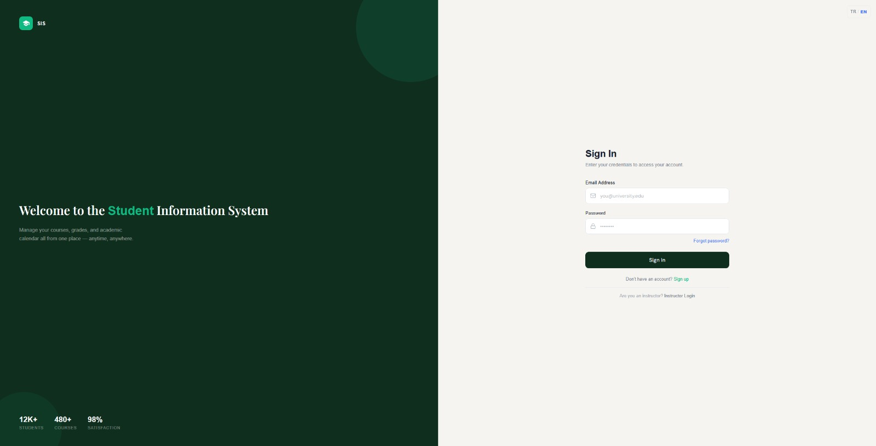

Figure A.2 – Student Registration Page
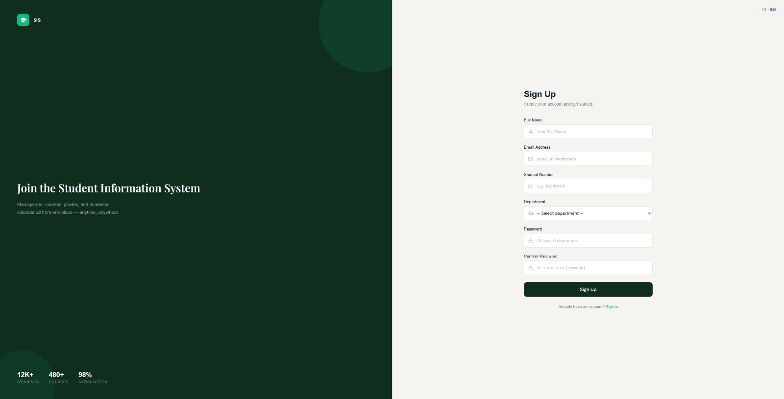

Figure A.3 – Student Dashboard
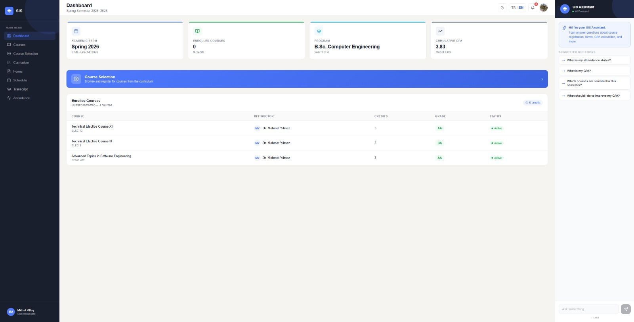

Figure A.4 – Courses Page
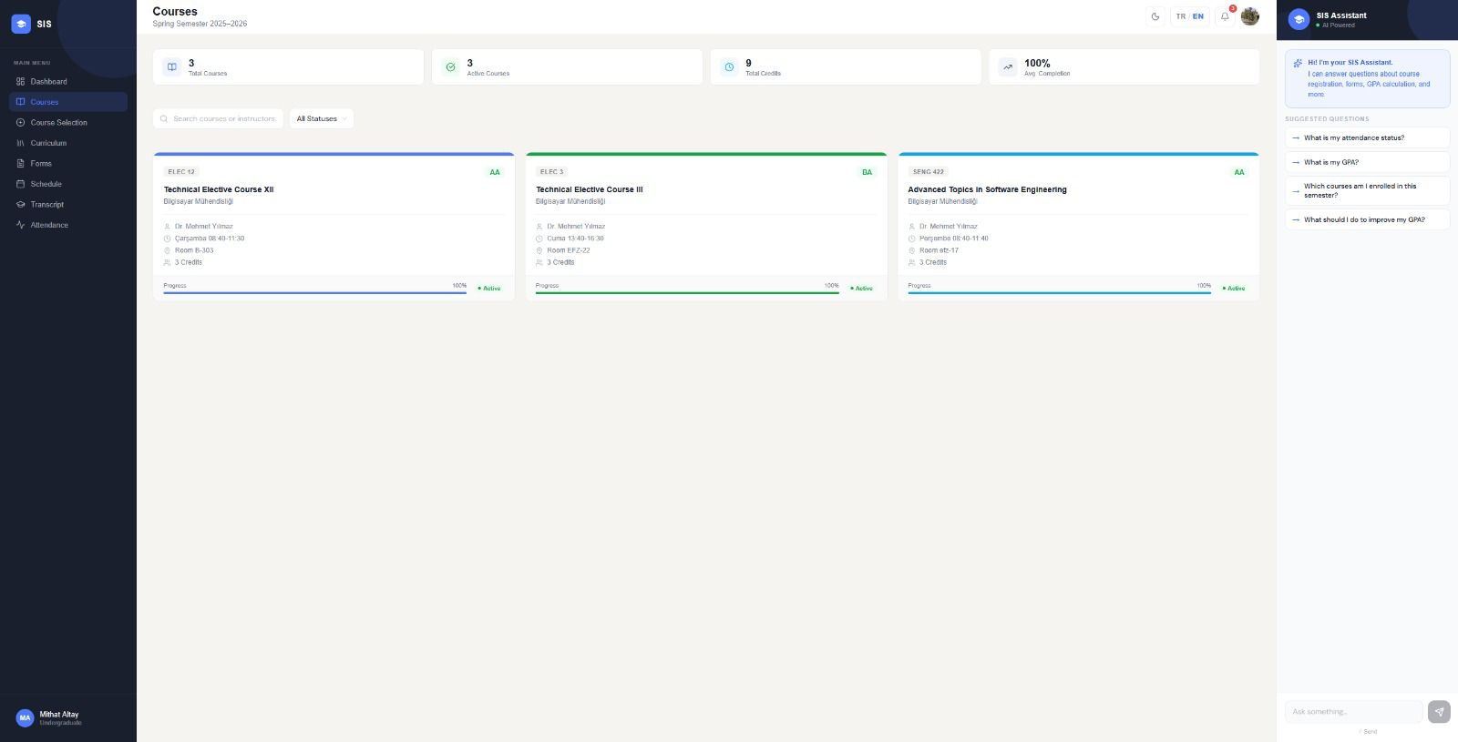

Figure A.5 – Weekly Schedule Page
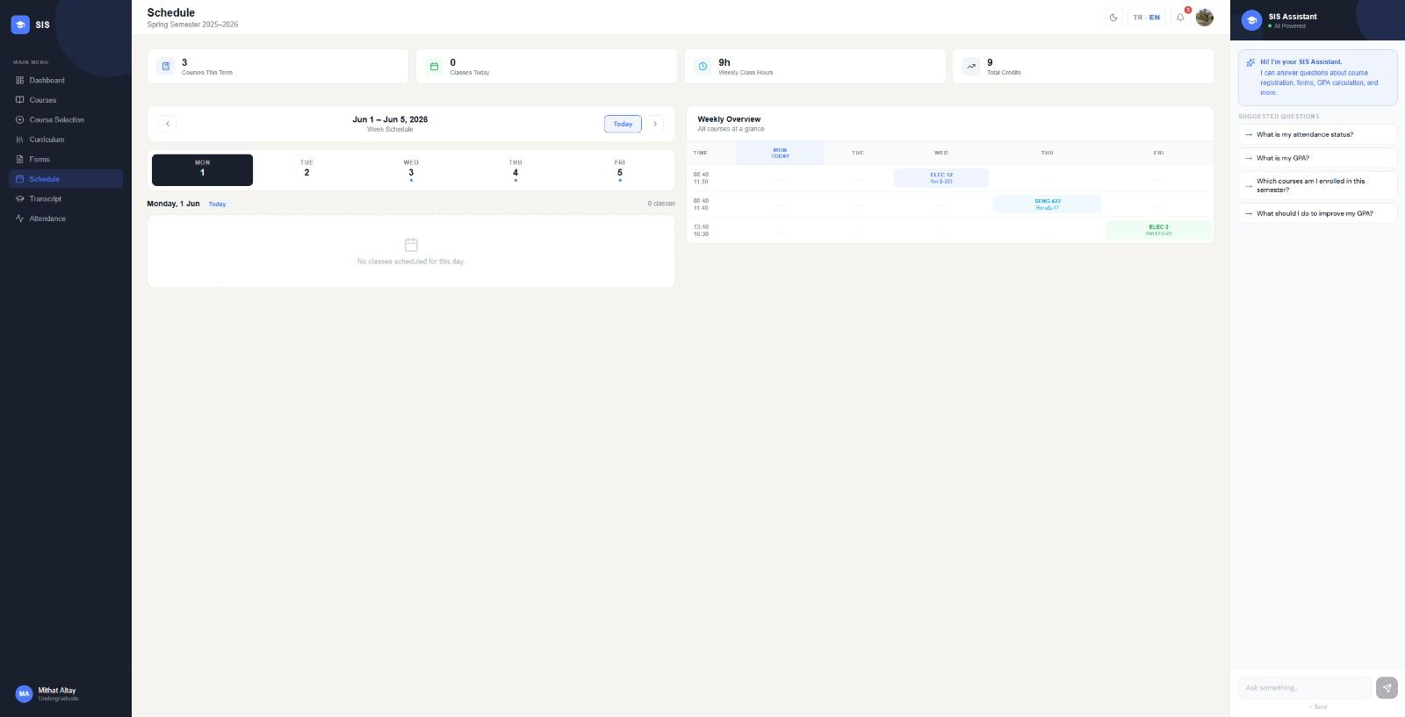

Figure A.6 – Attendance Page
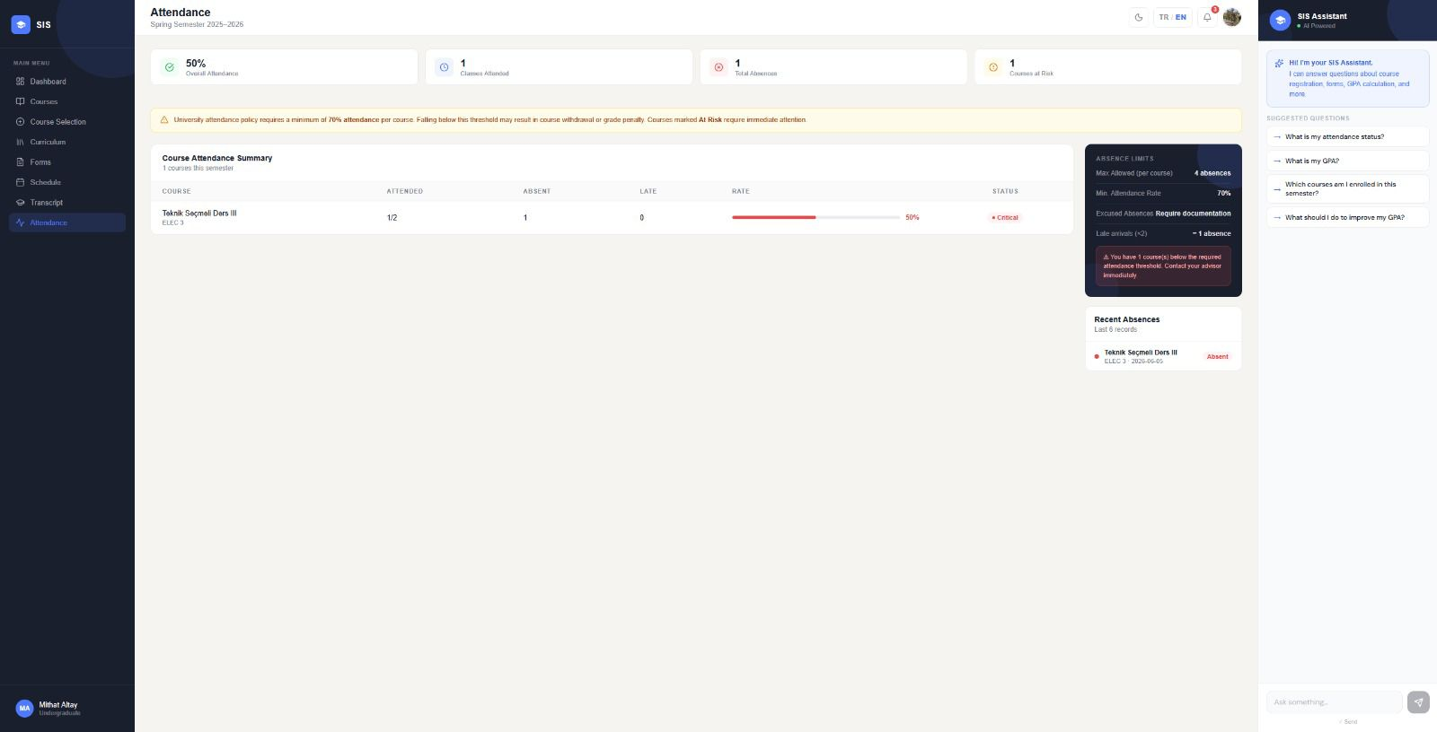

Figure A.7 – Transcript Page
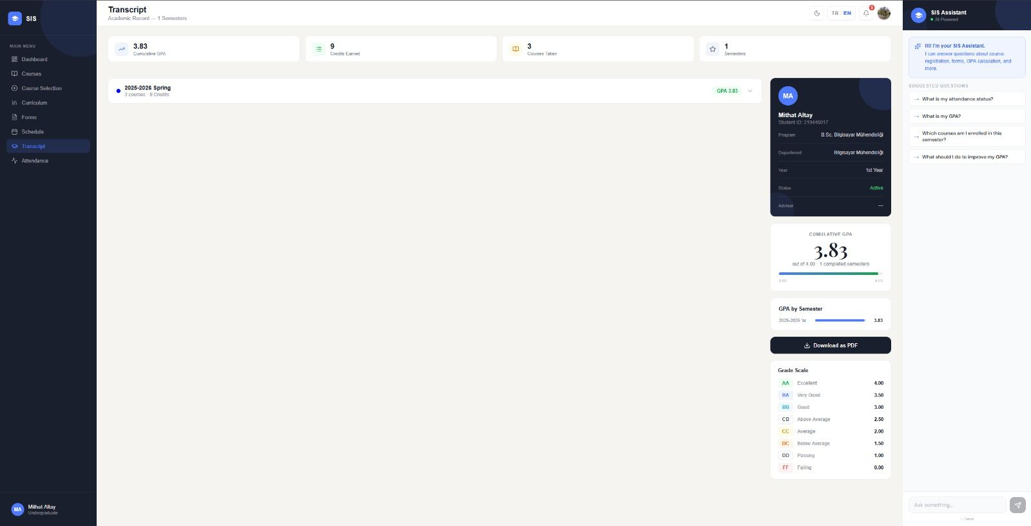

Figure A.8 – Curriculum Page
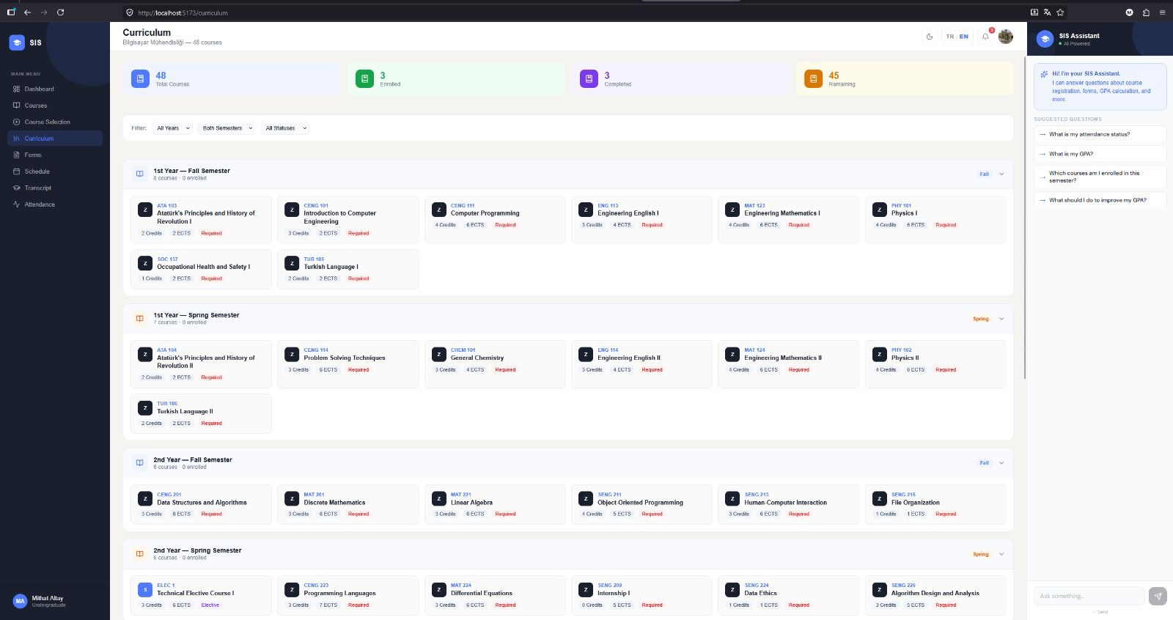

Figure A.9 – Course Selection / Enrollment Page
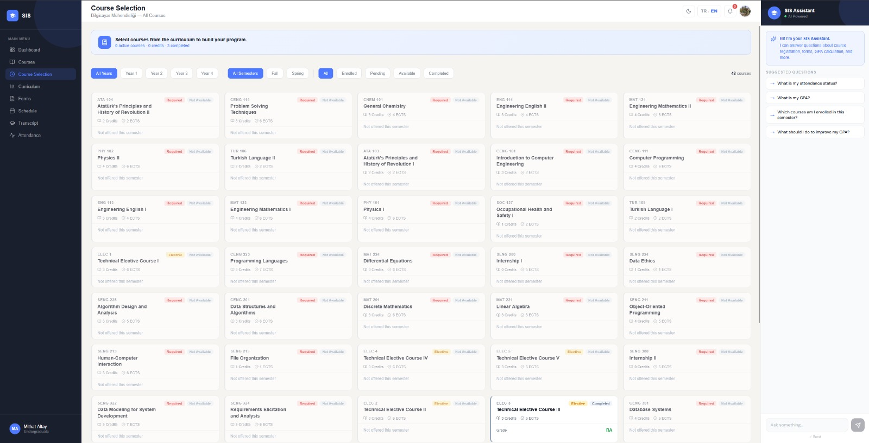

Figure A.10 – Administrative Forms Page
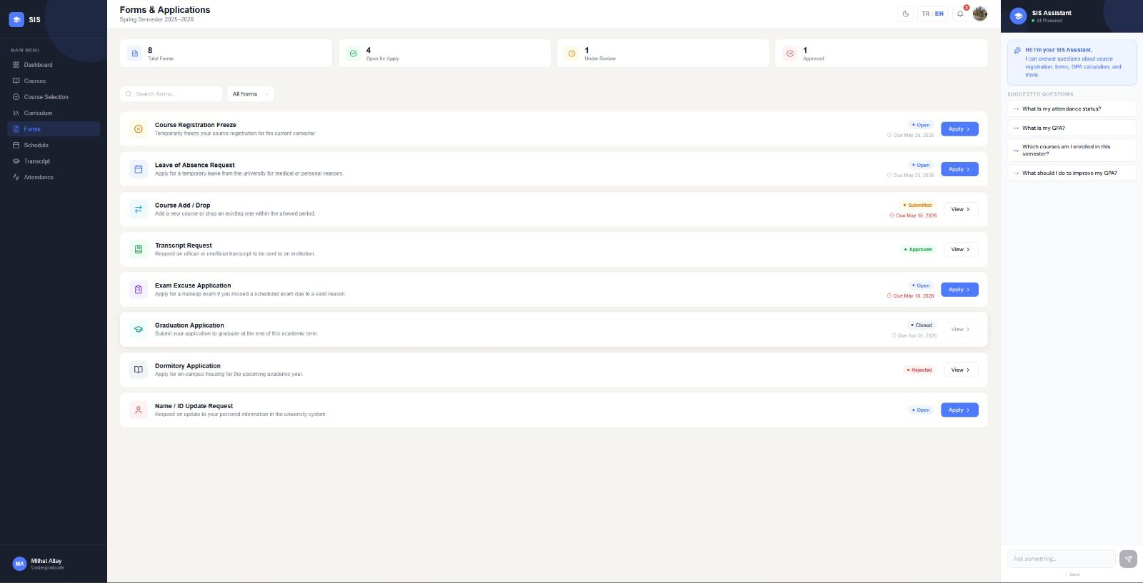

Figure A.11 – AI Chatbot
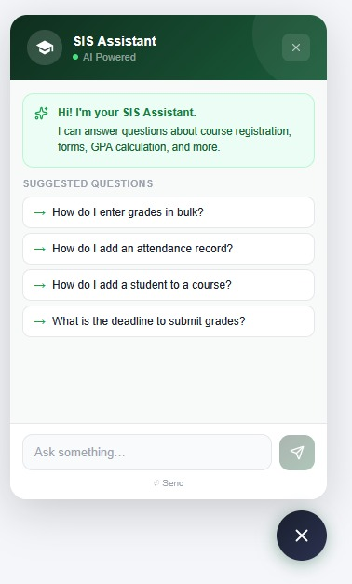

Figure A.12 – Instructor Login Page
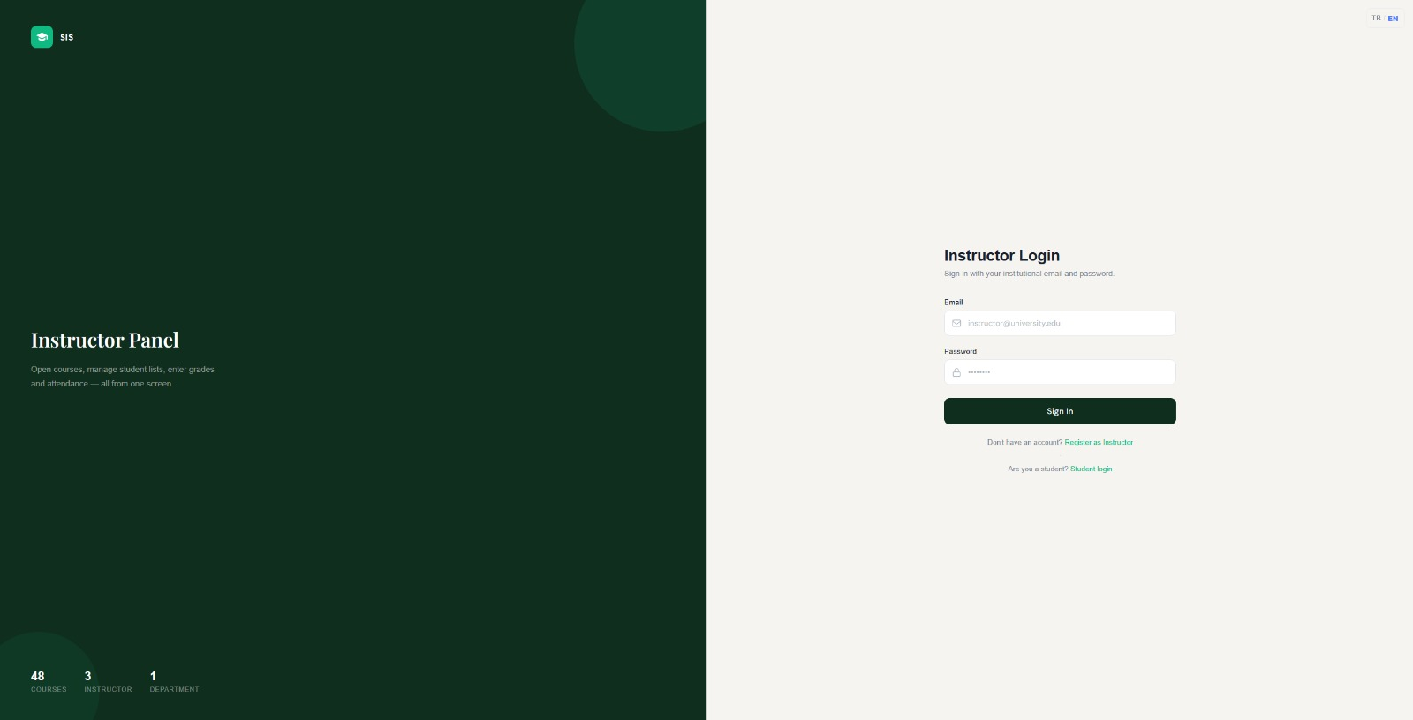

Figure A.13 – Instructor Courses
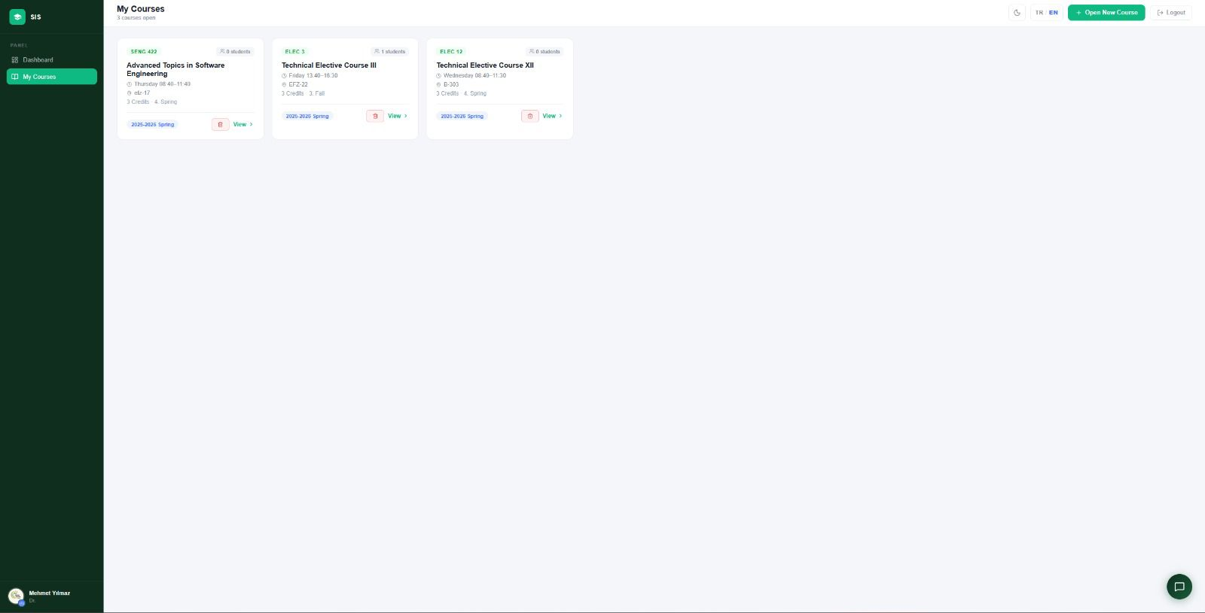

Figure A.14 – Dark Mode View
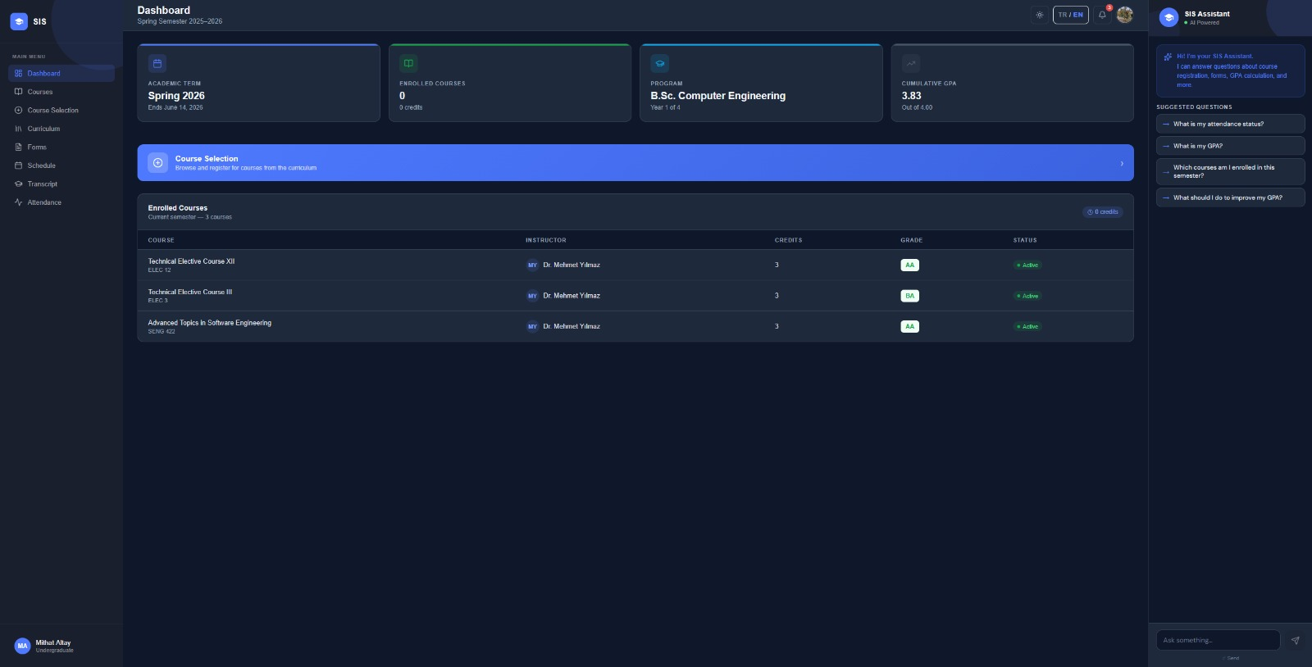

References
Brown, T., Mann, B., Ryder, N., Subbiah, M., Kaplan, J., Dhariwal, P., ... & Amodei, D. (2020). Language models are few-shot learners. Advances in Neural Information Processing Systems, 33, 1877–1901.
Devlin, J., Chang, M. W., Lee, K., & Toutanova, K. (2019). BERT: Pre-training of deep bidirectional transformers for language understanding. Proceedings of NAACL-HLT 2019, 4171–4186.
Liu, P., Yuan, W., Fu, J., Jiang, Z., Hayashi, H., & Neubig, G. (2023). Pre-train, prompt, and predict: A systematic survey of prompting methods in natural language processing. ACM
Pressman, R. S., & Maxim, B. R. (2019). Software Engineering: A Practitioner's Approach (9th ed.). McGraw-Hill Education.
Fowler, M. (2018). Refactoring: Improving the Design of Existing Code (2nd ed.). Addison-Wesley Professional.
React (2024). React — A JavaScript library for building user interfaces. Retrieved from https://react.dev
Prisma (2024). Prisma ORM Documentation. Retrieved from https://www.prisma.io/docs
Google (2024). Gemini API Documentation. Retrieved from https://ai.google.dev/docs
Express.js (2024). Express — Node.js web application framework. Retrieved from https://expressjs.com
OpenAI (2024). OpenAI API Reference. Retrieved from https://platform.openai.com/docs
Vite (2024). Vite — Next generation frontend tooling. Retrieved from https://vitejs.dev
JSON Web Tokens (2024). Introduction to JSON Web Tokens. Retrieved from https://jwt.io/introduction

